Project Planning Phase
Project Planning Template (Product Backlog, Sprint Planning, Stories, Story points)

Date | 31 October 2026
Team ID | NA
Project Name | Electric Vehicle Market Performance & Insights
Maximum Marks | 8 Marks

Product Backlog, Sprint Schedule, and Estimation (4 Marks)
Use the below template to create product backlog and sprint schedule
Sprint | Functional Requirement (Epic) | User Story Number | User Story / Task | Story Points | Priority | Team Members
Sprint-1 | Data Collection | USN-1 | Download the EV dataset (ev_market_test.csv) | 2 | High | Parvi Sharma
Sprint-1 | Data Preparation | USN-2 | Connect the CSV to Tableau and check types, nulls and duplicates | 3 | High | Parvi Sharma
Sprint-1 | Data Preparation | USN-3 | Create a Tableau extract | 2 | High | Parvi Sharma
Sprint-1 | Planning | USN-4 | Read the 3 scenarios and list the business questions | 3 | High | Parvi Sharma
Sprint-2 | Visualisation | USN-5 | EV Sales by Vehicle Category | 2 | High | Parvi Sharma
Sprint-2 | Visualisation | USN-6 | EV Sales Distribution Across Market Regions | 2 | High | Parvi Sharma
Sprint-2 | Visualisation | USN-7 | Top 10 EV Manufacturers by Annual Sales | 3 | High | Parvi Sharma
Sprint-2 | Visualisation | USN-8 | Average Driving Range by Vehicle Category | 2 | Medium | Parvi Sharma
Sprint-2 | Visualisation | USN-9 | Battery Technology Distribution | 3 | High | Parvi Sharma
Sprint-3 | Visualisation | USN-10 | Average Annual CO₂ Savings by Vehicle Category | 2 | High | Parvi Sharma
Sprint-3 | Visualisation | USN-11 | Top 10 Manufacturers by Customer Rating | 2 | Medium | Parvi Sharma
Sprint-3 | Visualisation | USN-12 | EV Sales by Model Year | 2 | Medium | Parvi Sharma
Sprint-3 | Dashboard | USN-13 | Design the EV Market Dashboard with region filter | 4 | High | Parvi Sharma
Sprint-3 | Story | USN-14 | Create the Tableau Story | 2 | Medium | Parvi Sharma
Sprint-4 | Deployment | USN-15 | Publish dashboard and story to Tableau Public | 2 | High | Parvi Sharma
Sprint-4 | Testing | USN-16 | Performance testing and checking values | 3 | High | Parvi Sharma
Sprint-4 | Documentation | USN-17 | Fill the templates and final report | 3 | High | Parvi Sharma
Sprint-4 | Demonstration | USN-18 | Record the demo video | 2 | Medium | Parvi Sharma
Sprint-4 | Deployment | USN-19 | Upload everything to GitHub | 2 | Medium | Parvi Sharma

Project Tracker, Velocity & Burndown Chart: (4 Marks)
Sprint | Total Story Points | Duration | Sprint Start Date | Sprint End Date (Planned) | Story Points Completed (as on Planned End Date) | Sprint Release Date (Actual)
Sprint-1 | 10 | 1 Day | 30 Oct 2026 | 30 Oct 2026 | 10 | 30 Oct 2026
Sprint-2 | 12 | 1 Day | 31 Oct 2026 | 31 Oct 2026 | 12 | 31 Oct 2026
Sprint-3 | 12 | 1 Day | 01 Nov 2026 | 01 Nov 2026 | 12 | 02 Nov 2026
Sprint-4 | 12 | 1 Day | 02 Nov 2026 | 03 Nov 2026 | 12 | 03 Nov 2026

Velocity:
Imagine we have a 10-day sprint duration, and the velocity of the team is 20 (points per sprint). Let’s calculate the team’s average velocity (AV) per iteration unit (story points per day)
For this project: 46 story points over 4 one-day sprints. Velocity = 46 ÷ 4 = 11.5 points per sprint; Average Velocity = 11.5 ÷ 1 day = 11.5 points per day.


Burndown Chart:
A burn down chart is a graphical representation of work left to do versus time. It is often used in agile software development methodologies such as Scrum. However, burn down charts can be applied to any project containing measurable progress over time.
Burndown chart of this project:
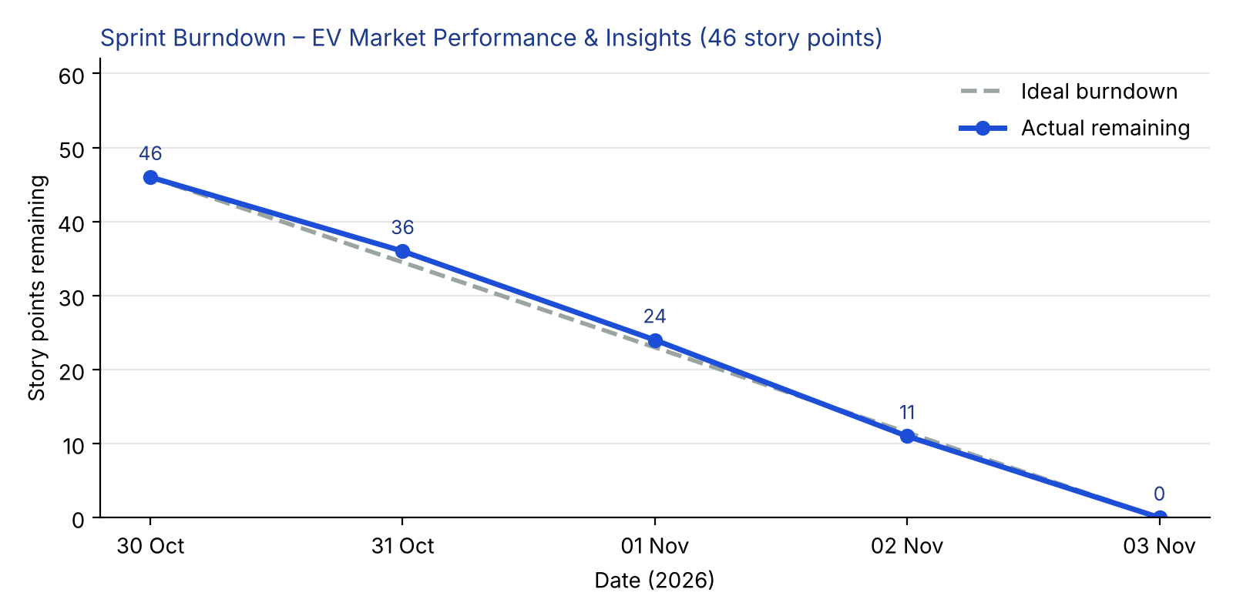

https://www.visual-paradigm.com/scrum/scrum-burndown-chart/
https://www.atlassian.com/agile/tutorials/burndown-charts

Reference:
https://www.atlassian.com/agile/project-management
https://www.atlassian.com/agile/tutorials/how-to-do-scrum-with-jira-software
https://www.atlassian.com/agile/tutorials/epics
https://www.atlassian.com/agile/tutorials/sprints
https://www.atlassian.com/agile/project-management/estimation
https://www.atlassian.com/agile/tutorials/burndown-charts

